Hazard Area Maps Have Changed
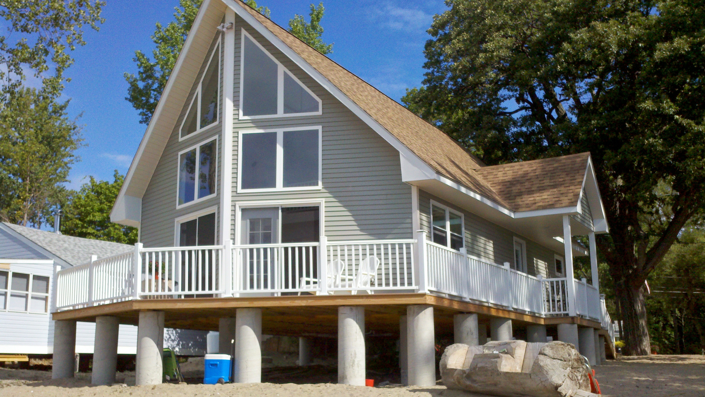
See if your property is at risk.

For the first time in decades, FEMA has updated the Special Flood Hazard Area maps that predict where flooding is most likely to occur. Their accuracy has improved. Some areas that were mapped as floodplain are no longer included. Other places have been newly identified as being at risk of flood damage.
Changes to land and buildings in these hazard areas are limited to keep the community safe. Check out the new maps at
bit.ly/flood-atlas View the Flood and River Corridor data under the Flood Ready Tools button to see the mapped hazard areas near you. Please contact us with any questions at [add contact information].
Flood Atlas

